Setting up SUNY Poly Gmail on your Mobile Device
On your Apple Device:
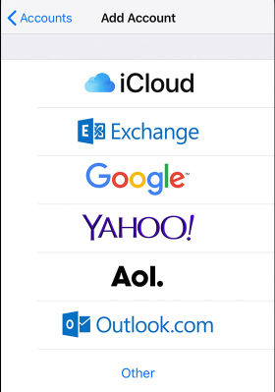
- Go to Settings > Passwords & Accounts, then tap Add Account. Select the Google option
- Tap Other, then tap Add Mail Account.
- Enter your name, email address, password, and a description for your account. Your email account is “Your SitNet ID”@sunypoly.edu
- Tap Next. Mail will try to find the email settings and finish your account setup. If Mail finds your email settings,
tap Done to complete your account setup.

On your Android Device:
- On your Android phone or tablet, open Settings. Settings.
- Select Accounts
- Select Add Account
- Select Google from the list.
- Tap Add account.
- Follow the steps on the screen to add your account. Your email account is “Your SitNetID”@sunypoly.edu

