Formatting an APA References Page with Hanging Indents

Type "References" at the top of a page.
Type your references out normally: don't double space the document or indent anything. (Putting words in italics can be done at any time. It is not related to this formatting.)

1. Center "References"
2. Select the entire References section, from the word "References" to the end of the last citation.
3. Click on the expand icon in the Paragraph section of the HOME tab:
4. Under Indentation, Special, select "Hanging"
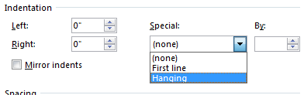
Make sure Indentation, Left and Right are set to "0""

5. Under Spacing, Line spacing, select "Double"
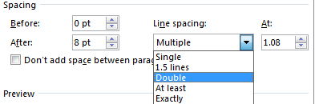

6. Click on the "OK" button.

