Type “References” at the top of a page, bolded, flush left, with no quotation marks. Like this:
References
Type your references out normally: don't double space the document or indent anything. (Putting words in italics can be done at any time. It is not related to this formatting.)

1. Select all the References, from the first citation under References to the end of the last one.

2. Click on the expand icon in the Paragraph section of the HOME tab:

3. Under Indentation, Special, select "Hanging"
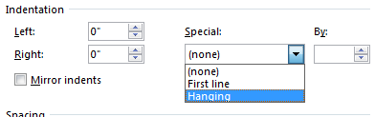
Make sure Indentation, Left and Right are set to "0""

4. Under Spacing, Line spacing, select "Double"
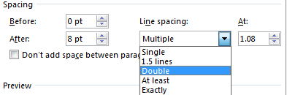

5. Click on the "OK" button.

